Souls of the Forgotten | Target Audience: 10+ fans of narrative games, fantasy, JRPGs  Gamer Type: Core  Target Platforms: PC  Genre: narrative exploration / light RPG  Number of Players: 1, Solo  Projected Release Date: Prototype in ¾ weeks

Concept Image

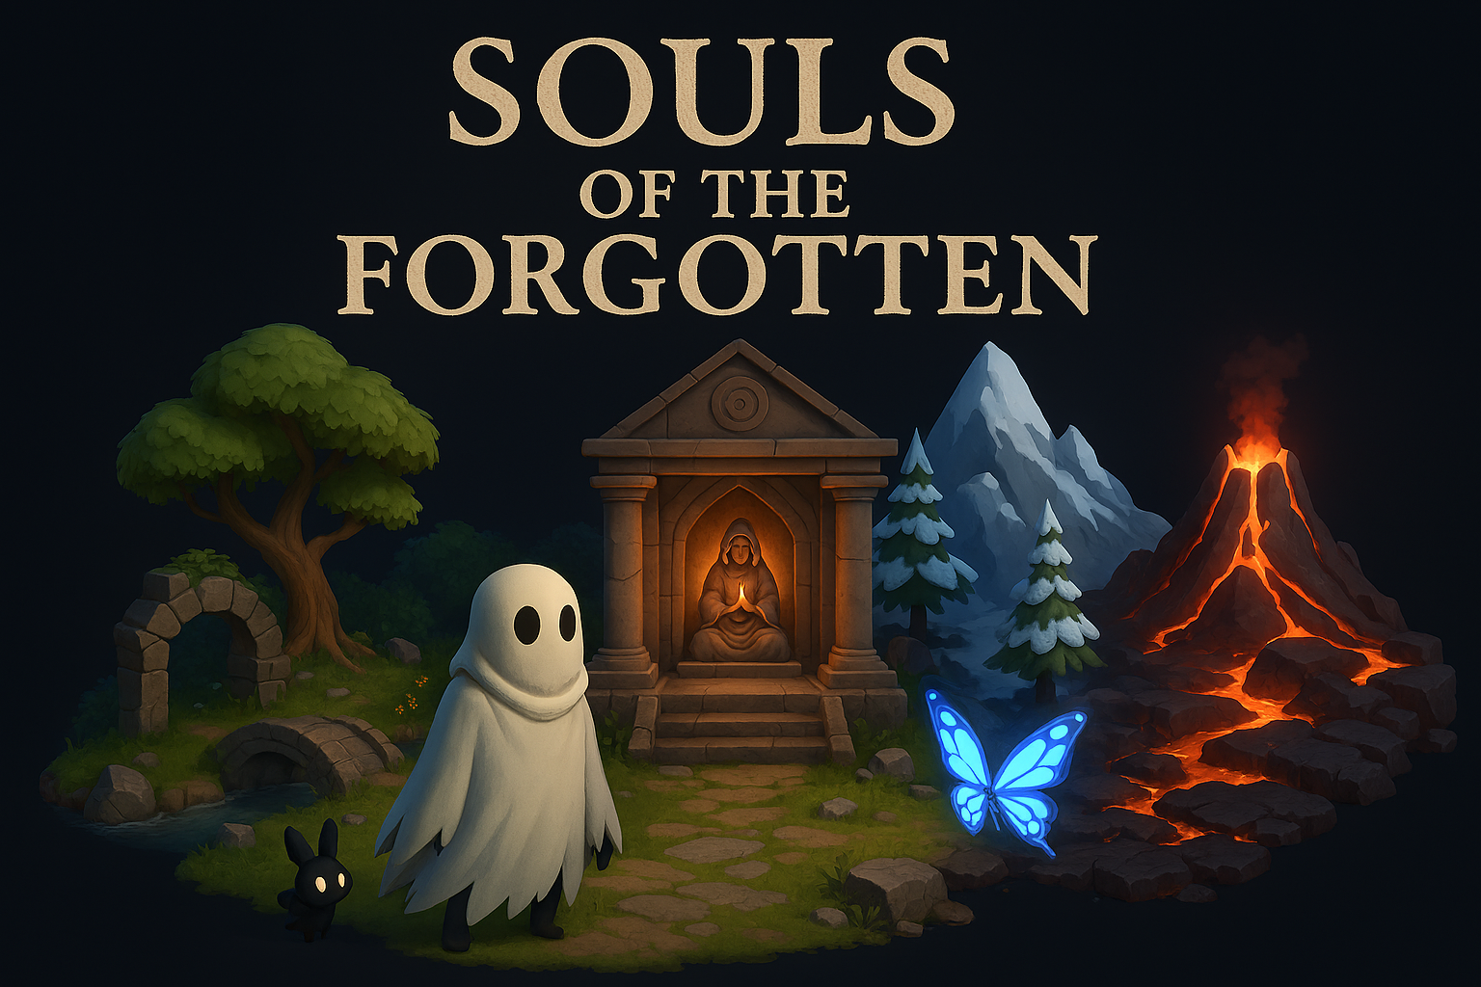

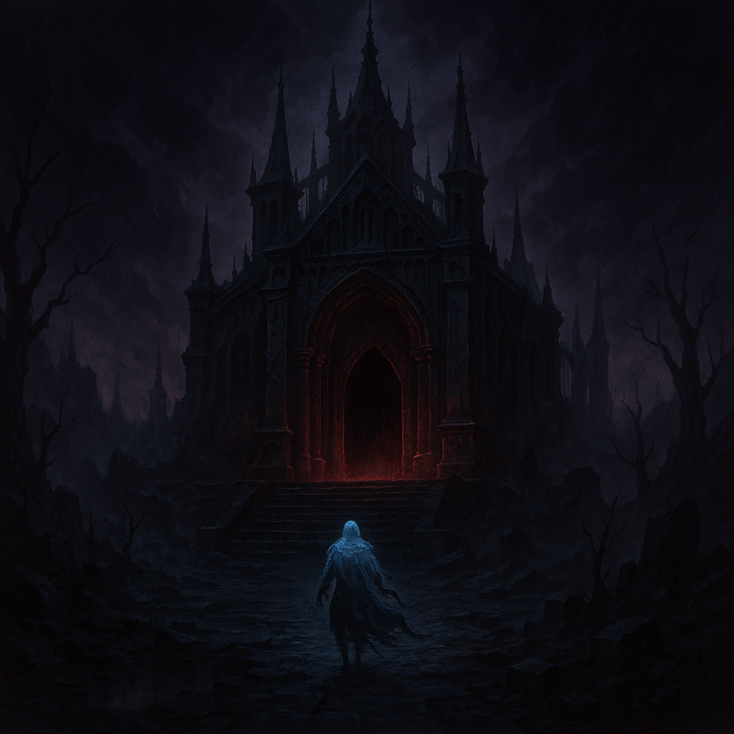
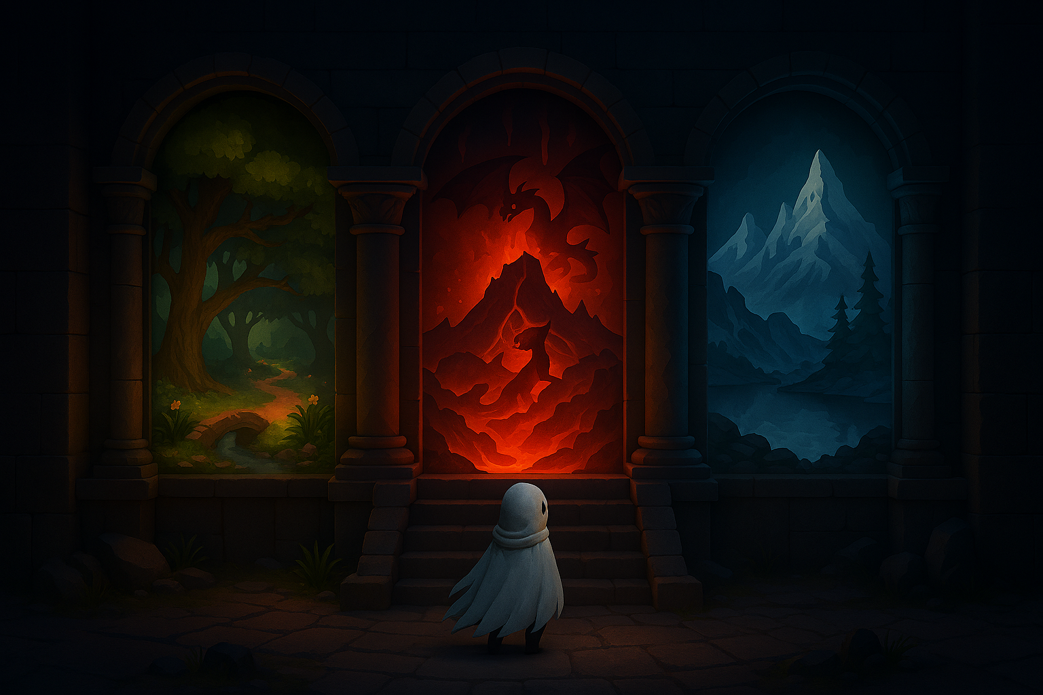

Elevator Pitch (High Concept Statement)

Souls of the Forgotten is a narrative exploration game designed for core gamers aged 16 and up who enjoy emotional storytelling, dark fantasy worlds, and spiritual themes. The player takes on the role of a ghost who awakens in a forgotten underground prison with no memory of who they are or why they were condemned. Guided by a mysterious voice and a small companion, the player embarks on a journey to recover their identity by visiting three sacred shrines scattered across a mystical, ruined world.

The soul of the game lies in its emotional progression: each shrine grants a blessing that transforms the ghost physically and mentally—first into a humanoid form, then a shadow-human, and finally a fully restored human. These transformations are tied to memory recovery, revealing personal truths and the deeper purpose behind the character’s existence. The gameplay focuses on exploration, environmental storytelling, and light puzzle-solving, with intuitive controls and a linear flow that guides the player through each stage of their metamorphosis.

Set in a hauntingly beautiful world inspired by classic JRPGs like Final Fantasy VI and Hollow Knight, the game evokes feelings of mystery, melancholy, and hope. The visual style blends pixel art with atmospheric lighting, while the sound design features ambient music and ethereal voiceovers to deepen immersion. What makes Souls of the Forgotten unique is its transformation mechanic tied directly to narrative progression, offering a spiritual journey rather than a traditional power fantasy. The game is developed for PC using Unity, with a scope tailored for solo development and a first playable version planned within 3–4 weeks.

Feature Set (Pillars of the Game)

- Transformation mechanic: ghost → humanoid → shadow-human → full human
- Environmental storytelling through murals and voice narration
- Companion system (small familiar that guides the player)
- Exploration of three distinct sacred zones
- Visual evolution of the character tied to memory recovery
- Atmospheric sound design and mystical art style

Design Influences

- Games: Final Fantasy VI & IX, Hollow Knight, Journey, Ori and the Blind Forest
- Films: Spirited Away, The Others
- Books: The little prince
- Unique twist: Unlike other games, the transformation mechanic is tied to memory recovery and emotional growth, not just power progression.

Game Flow and/or Game Loop

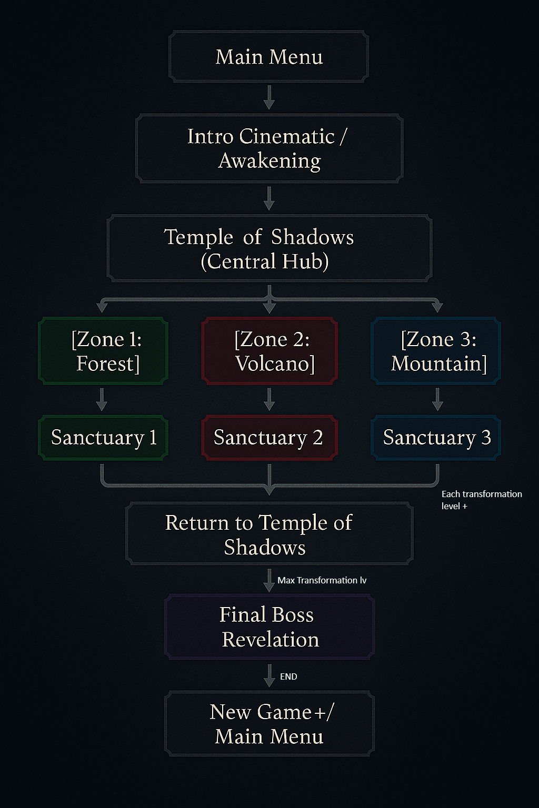
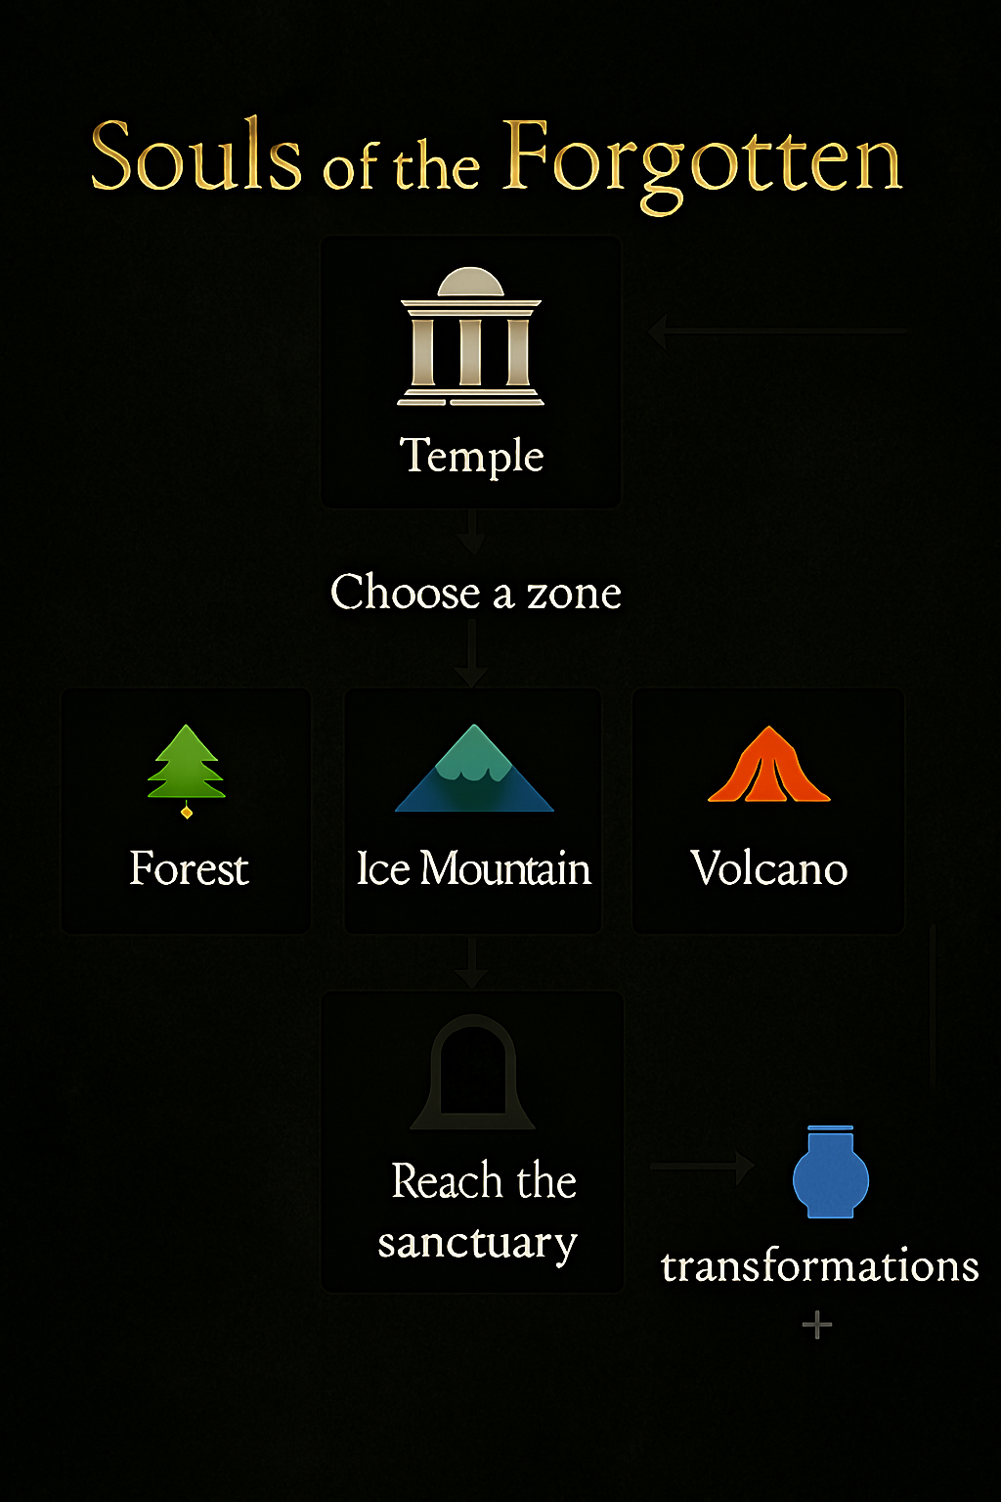

Scope Management
- Green Light Features (High Priority)
- Yellow Light Features (Medium Priority)
- Red Light Features (Low Priority)

Green Light Features (High Priority)
- Intro zone (prison + first shrine)
- First transformation
- Companion system
- Basic exploration and movement
- Voice narration or text-based story fragments

Yellow Light Features (Medium Priority)
- Second and third shrine zones
- Full transformation system
- Environmental puzzles
- Advanced companion behavior

Red Light Features (Low Priority)
- Boss fight
- Full soundtrack
- Power Ups
- Complex UI/inventory
- Side quests or alternate endings

